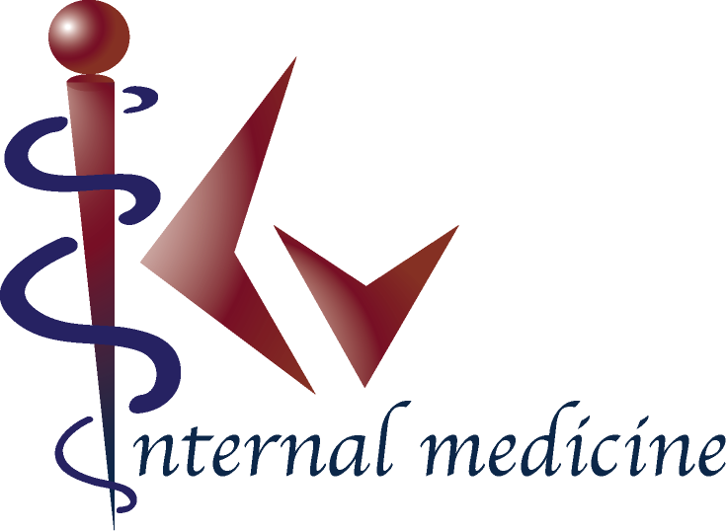

Patient Portal Policy and Procedures.

KHIEM VU, DO PA in partnership with e-MDs® provides the Patient Portal exclusively to established patients. The goals of the Patient Portal are to facilitate communication between the patient and the clinic, allow the patient to monitor laboratory results, and to track their own records. KHIEM VU, DO PA maintains the information on the Patient Portal at its current physical facility.

We strive to keep all the information in your records accurate and complete. If you identify any discrepancy on your records, you agree to notify us immediately. Thus by agreeing to use the patient portal, the user agrees to provide accurate information to KHIEM VU, DO PA.

Policies and Limitations
The Patient Portal is provided as a courtesy to our established and current patients. If in the event of abuse or negligent usage of the Patient Portal persists, we reserve the right at our own discretion to terminate Patient Portal offering, suspend user access, or modify services offered through the Patient Portal. In addition, the following policies and limitations apply:
  - Do not use portal communication if there is an emergency. Please dial 911 or go to the Emergency Room.
  - No internet based triage and treatment request.
  - Sensitive subject matter (HIV, mental health, work excuses, etc.) is not permitted.
  - No request for narcotic pain medication will be accepted through the portal.
  - No request for refill medication not currently being treated by our provider.

After you agree to the Policy and Procedures and sign the Consent Form, we will attempt to send a “welcome message” email to you. This will provide a link to the Portal login screen. (If you have not received an email from us within 5 working days, please CALL the office. We will not respond directly to your email. All electronic communications must be through the Patient Portal.)

We will normally respond to non-urgent email inquires within 5 business days after receipt. (If you have not received an email from us within 5 working days, please CALL the office.)

Guidelines and Security
KHIEM VU, DO PA offers secure viewing and communication to our patients who wish to view parts of their records and communicate with our staff. The Patient Portal is provided in partnership with e-MDs on HIPAA compliant VPN with high level encryption that exceeds the HIPAA standards. However, it does not guarantee that unforeseen adverse events cannot occur. All new and established patients have signed the HIPAA agreement form. If you need to reacquaint with our HIPAA policy, a copy can be provided to you for your review. While secure messaging can be valuable, it has certain risks. To reduce these risks we need to impose some conditions of participation. By signing our Consent Form you accept the risks and agree to the conditions of participation. Once this form is agreed to and signed, we will send you an email notification that tells you how to log in for the first time. Please keep this email in a safe place for future reference.

You should be able to log in using the user name and password provided. Once logged into the portal, you should go to “My Account” on the top right of the page. Here you can change your user name and password to something only you will know. This is essential to make sure your information remains secure and private!

Protecting Your Private Health Information and Risks
While we strive to ensure that all communication through the portal is secure, keeping it secure depends on two additional factors: the secure message must reach the correct email address, and only the correct individual (or someone authorized by that individual) must be able to get access to it. You need to make sure we have your correct email address and you MUST inform us if it ever changes. If you think someone has learned your password, you should promptly go to the Patient Portal and change it or contact us. You can also use the “forgot password” option on the portal, or call our office, to reset your password. We will strive to make all information as confidential as possible. Your email address and any private information will NEVER be sold or given away.

